Download Istio
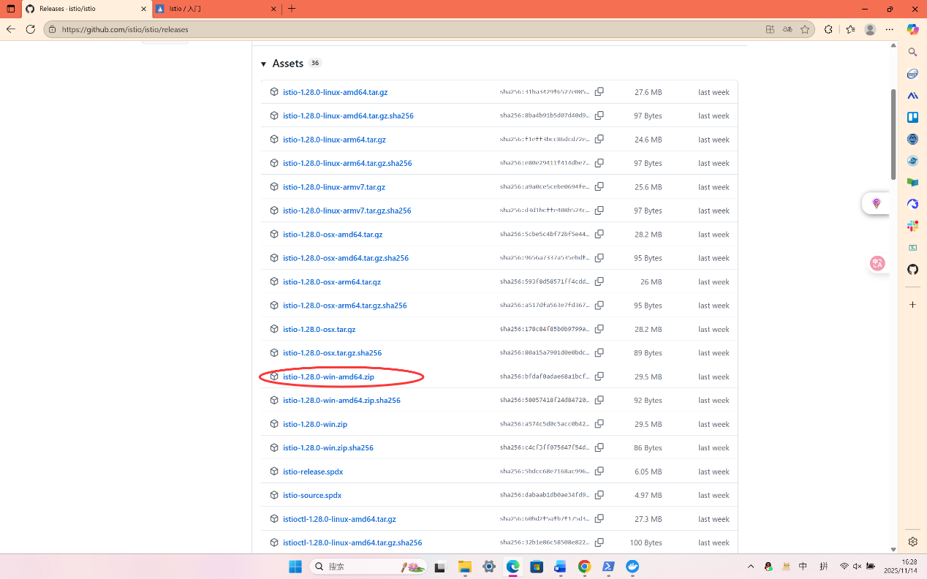
Install Istio
- Install Istio using the demo profile, without any gateways:
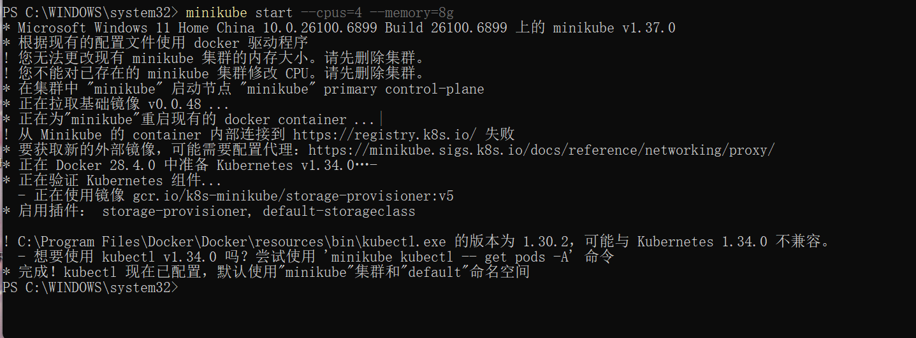
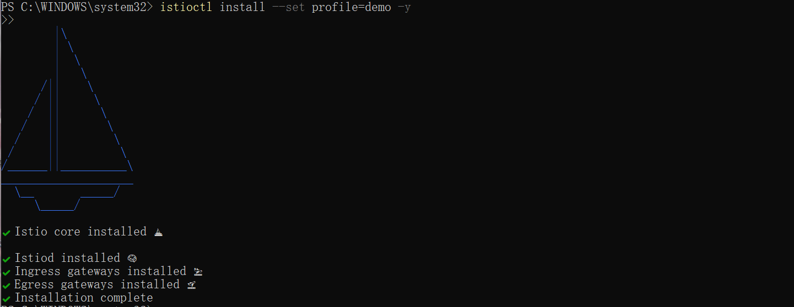
- Add a namespace label to instruct Istio to automatically inject Envoy sidecar proxies when you deploy your application later:
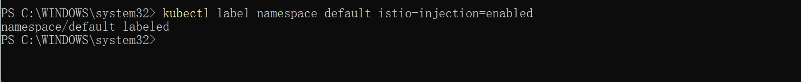
Install the Kubernetes Gateway API CRDs
- Install the Gateway API CRDs, if they are not already present:
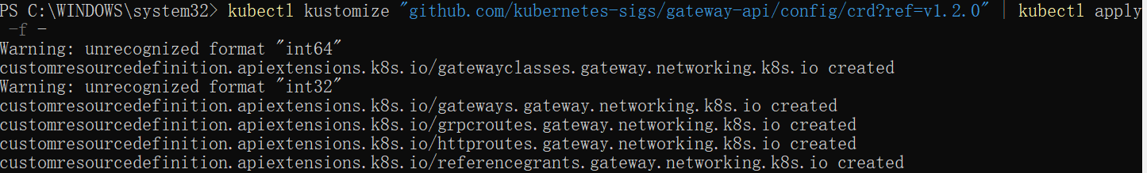
Deploy the sample application
- Deploy the Bookinfo sample application:
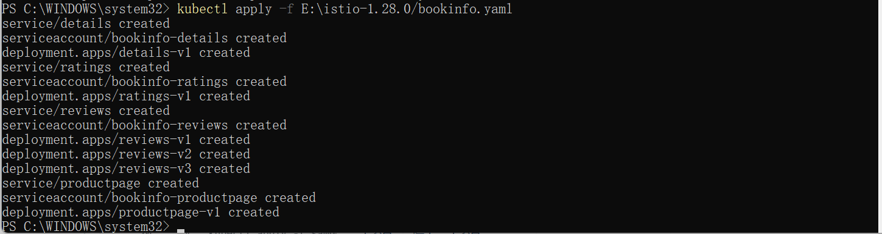
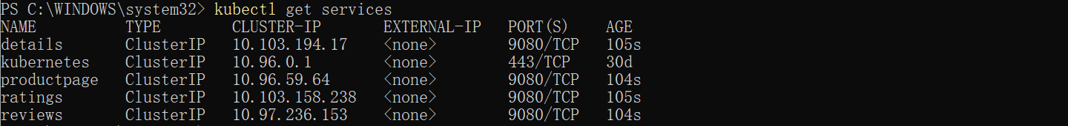
- Validate that the app is running inside the cluster by checking for the page title in the response:
Open the application to outside traffic
- Create a Kubernetes Gateway for the Bookinfo application:
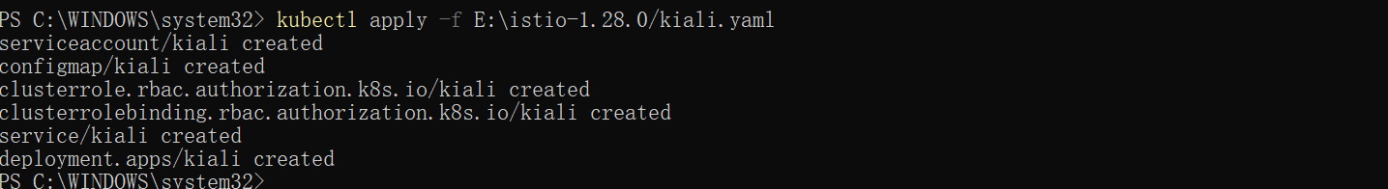
- Change the service type to ClusterIP by annotating the gateway:
Access the application
- 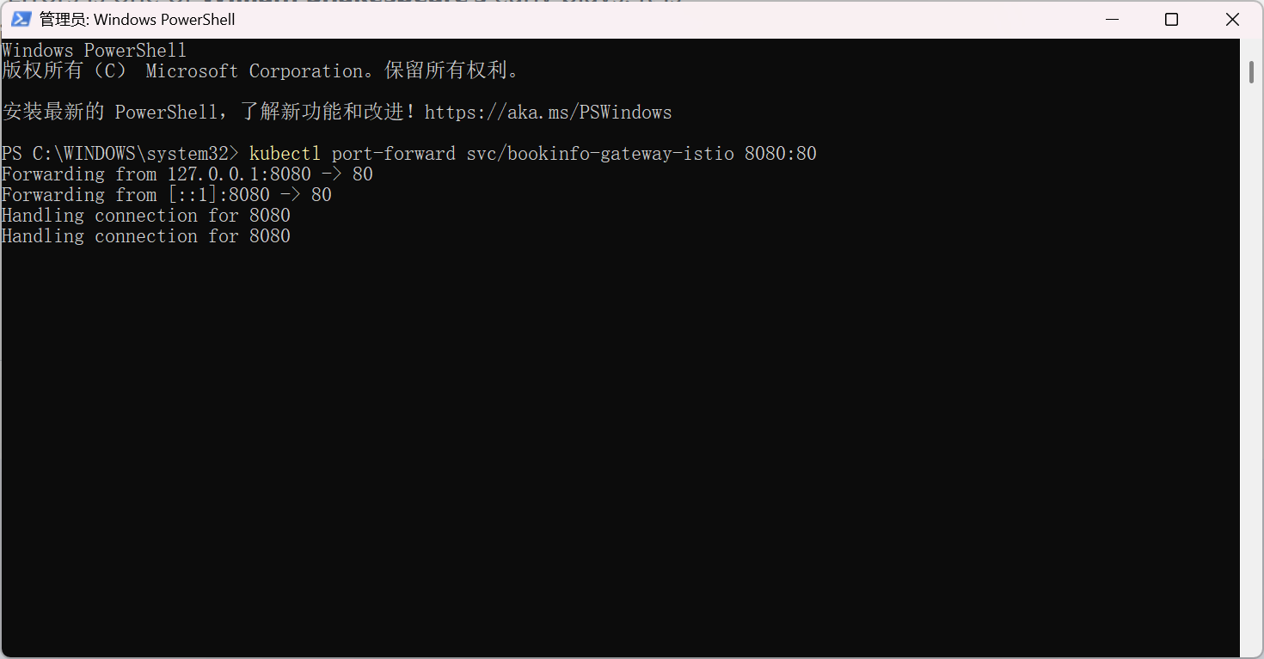
- 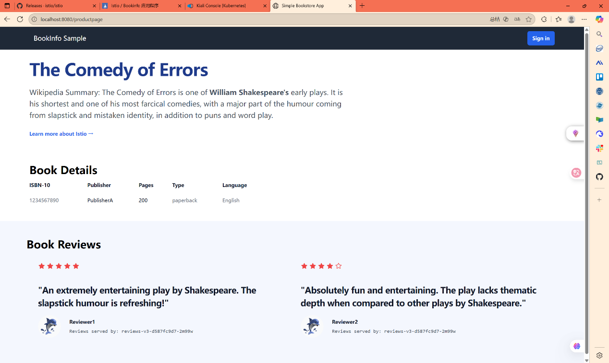
View the dashboard
- Install Kiali and the other addons and wait for them to be deployed.

 